Windows Services Screenshots

1. Screenshot of installutil WinService.exe

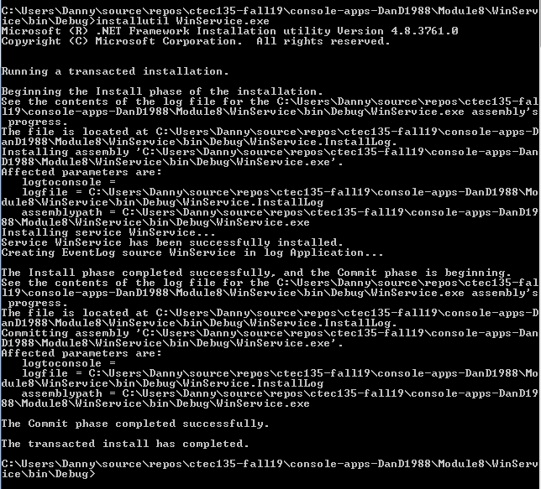

1. Screenshot of WinService start, pause, stopped







